|  |
| --- |
|  |
| IntegrateX INSTALLATION GUIDE  Installation Guide |
| Developed & Presented By **Blazor Technologies Inc, Pakistan** |
|  |

# 

# 

**Table of Contents**

IntegrateX Installation Guide 2

Pre-Requisites 2

Release Contents 2

Deployment Steps 3

Roll Back Steps 4

# IntegrateX Installation Guide

|  |  |
| --- | --- |
| **Document Name:** | Installation Guide |
| **Version:** | V1.0 |
| **Location of delivery:** | Jira Online |
| **Mode of delivery:** |  |
| **Date approved:** | 26 July 2021 |

IntegrateX is bot engine for hoteling industry, it gets data from integrated PMS systems & GuestX system based on page or form scan. For more details, see BDU SOW V1.5.pdf

# Pre-Requisites

|  |  |
| --- | --- |
| GuestX Backend | PHP 7.4, Laravel Framework |
| IntegrateX | Windows 10+, Mac 10.14.+ |
| Browser | Chrome 91.0.4472.164 |

# Release Contents

|  |  |
| --- | --- |
| IntegrateX | IntegrateX.msi |
| IntegrateX API | PHP {REST} API |
| CMS Database | Migration Scripts |

# Deployment Steps

1. **Backup**

* GuestX Database
* GuestX PHP Deployment Release

1. **Installation**

* GuestX PHP Deployment, xcopy of PHP code.
* Update .inv file from root directory, add/ update entry of

“*BDU_API_URL=http://bduapi.btserver.com*”

* Run “IntegrateX.msi” installer or download from live guestX application.

Change “app.config” file, it’s located in IntegrateX installation folder. Add/ update API URI.., as shown below

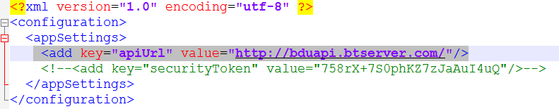

1. **Test Installation**

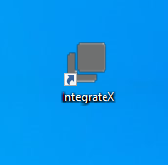

* Double click on shortcut IntegrateX.
* Open login form.

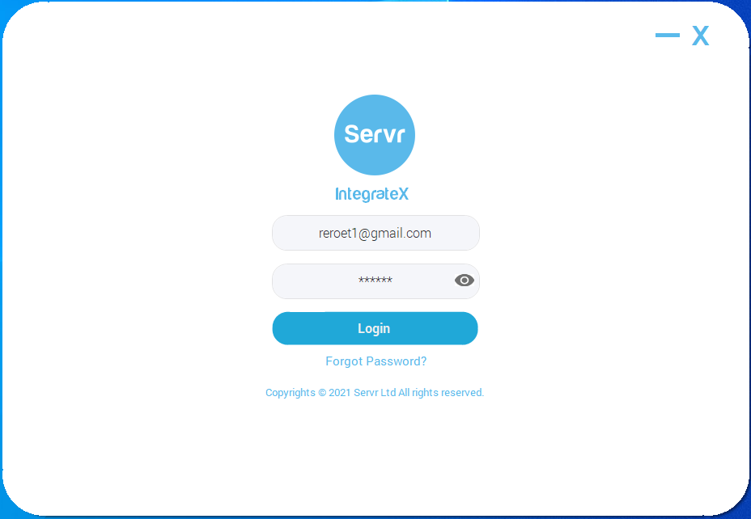

* Enter User Name “[reroet1@gmail.com](mailto:reroet1@gmail.com)”.
* Password “xxx”.
* Click on “Login” button.
* Login Successful.

# Roll Back Steps

* Restore GuestX Database backup.
* Overwrite GuestX PHP backup
* Uninstall IntegrateX from control panel “Client Machines”.